M: “What is the best thing about music?”
How a song can be used as both a form of therapy for some, as well as a strategy which assists some in productivity.
U: “What is the ugliest colour for a vehicle?”
Mushy Peas Green
S: “Name a singer you think has an awesome voice.”
Dimash Kudaibergen
I: “If you had a pet iguana, tell us its full name.”
Haku Grant Lavigne
C: “Have you ever been to a live concert?”
No
T: “What do you think is the most important technological advancement in the last 125 years?
In 1958, the first videos games, microchips and modems were created
E: “Tell us the most excellent food and why you think it’s the best”
Chocolate oranges.
C: “What is your favorite colour, and name something that is that colour.”
Light Blue, like the sky
H: “Share a picture of the craziest hair you can find on the internet”
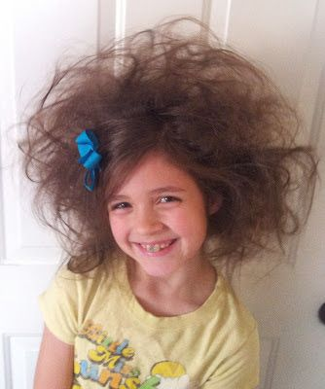
C: Country Music, yes or no? Give reasons for your answer.
No, I find country music repetitive, and often then not, they follow a similar style of lyrics, a similar rhythm, and often have a southern style vocal, which I personally dislike.
L: What is something you would like to learn this semester?
I’d like to hone my skill in technology, with the musical side being a perk.
A: Most exciting adventure you ever had?
I haven’t really had many exciting adventures before.
S: Top 5 favorite songs
idontwannabeyou - Billie Eilish
Wonderwall – Oasis
Say It Ain’t So - Weezer
Waving Through a Window - Dear Evan Hansen
Creep - Radiohead
S: Describe your singing ability using an adjective and a type of animal.
Screeching Hyena

